CSA1409 – COMPILER DESIGN
LAB EXERCISE
Name: Poornima .S
Reg. No.:192521315

1. Lex program – Email
Lex program

%option noyywrap
%{
#include <stdio.h>
%}

%%

^[A-Za-z0-9._%+-]+@[A-Za-z0-9.-]+\.[A-Za-z]{2,}$ {
printf("\nEmail is VALID\n");
}

^[^\n]+$ {
printf("\nEmail is INVALID\n");
}

\n ;

%%

int main()
{
printf("Enter Email: ");
yylex();
return 0;
}
Output :
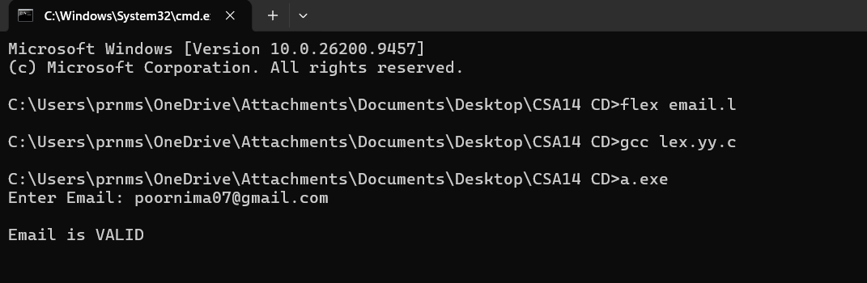

2. Write a LEX specification file to take input C program from a .c file and count tthe number of characters, number of lines & number of words.

%{
#include <stdio.h>
#include <stdlib.h>

// Global variable counters initialized to zero
int nchar = 0;
int nword = 0;
int nline = 0;
%}

%%

\n { nline++; nchar++; }
[^ \t\n]+ { nword++; nchar += yyleng; }
. { nchar++; }

%%

int yywrap(void) {
return 1;
}

int main(int argc, char *argv[]) {
if (argc < 2) {
printf("Usage: %s <filename.c>\n", argv[0]);
return 1;
}

yyin = fopen(argv[1], "r");
if (!yyin) {
printf("Error: Could not open file '%s'\n", argv[1]);
return 1;
}

yylex();

printf("Number of characters = %d\n", nchar);
printf("Number of words = %d\n", nword);
printf("Number of lines = %d\n", nline);

fclose(yyin);
return 0;
}

Output :

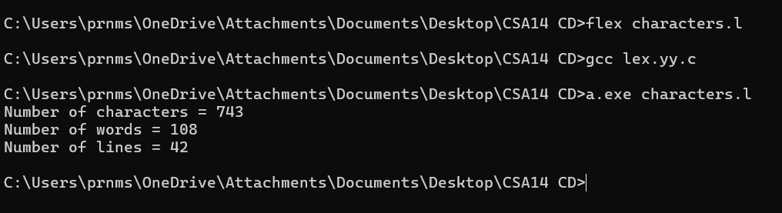

3. Write a LEX program to print all the constants in the given C source program file.

%{
#include <stdio.h>
#include <stdlib.h>
%}

%%

[0-9]+(\.[0-9]+)? { printf("Constant: %s\n", yytext); }
\"([^\"\\\n]|\\.)*\" { printf("Constant: %s\n", yytext); }
\'([^\'\\\n]|\\.)\' { printf("Constant: %s\n", yytext); }

%%

int yywrap(void)
{
return 1;
}

int main(int argc, char *argv[])
{
if (argc < 2)
{
printf("Usage: %s <filename.c>\n", argv[0]);
return 1;
}

yyin = fopen(argv[1], "r");

if (yyin == NULL)
{
printf("Error: Cannot open file\n");
return 1;
}

yylex();

fclose(yyin);
return 0;
}

Output :
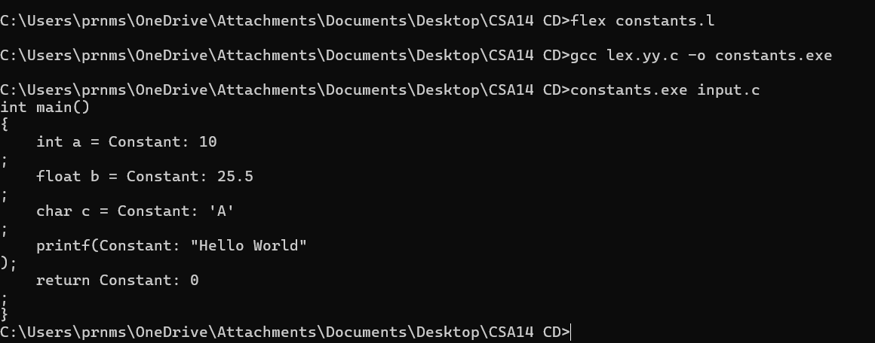

4. Write a LEX program to count the number of Macros defined and header files included in the C program.

%{
#include <stdio.h>
#include <stdlib.h>

int macros = 0;
int headers = 0;
%}

%%

^[ \t]*#[ \t]*define[ \t]+[A-Za-z_][A-Za-z0-9_]* { macros++; }
^[ \t]*#[ \t]*include[ \t]*[<"][^>\"]+[>"] { headers++; }

%%

int yywrap(void)
{
return 1;
}

int main(int argc, char *argv[])
{
if (argc < 2)
{
printf("Usage: %s <filename.c>\n", argv[0]);
return 1;
}

yyin = fopen(argv[1], "r");

if (yyin == NULL)
{
printf("Error: Cannot open file\n");
return 1;
}

yylex();

printf("Number of macros defined = %d\n", macros);
printf("Number of header files included = %d\n", headers);

fclose(yyin);
return 0;
}

Output

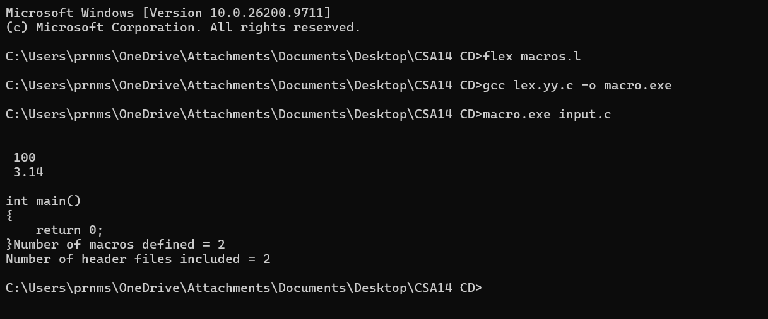

5. Write a LEX program to print all HTML tags in the input file.

%{
#include <stdio.h>
#include <stdlib.h>
%}

%%

"<"[^>]+">" { printf("%s\n", yytext); }

%%

int yywrap(void)
{
return 1;
}

int main(int argc, char *argv[])
{
if (argc < 2)
{
printf("Usage: %s <filename.html>\n", argv[0]);
return 1;
}

yyin = fopen(argv[1], "r");

if (yyin == NULL)
{
printf("Error: Cannot open file\n");
return 1;
}

yylex();

fclose(yyin);
return 0;
}

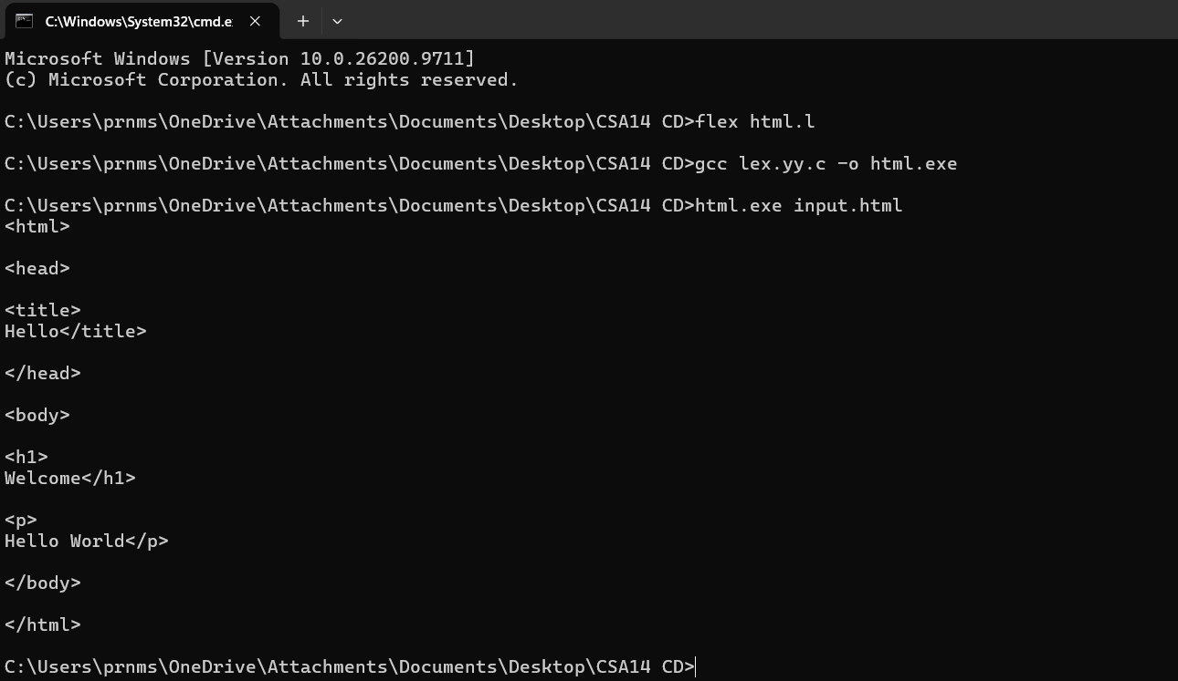

6. Write a LEX program which adds line numbers to the given C program file and display the same in the standard output.

%{
#include <stdio.h>
#include <stdlib.h>

int line = 1;
%}

%%

\n { printf("\n"); line++; printf("%d: ", line); }
. { printf("%s", yytext); }

%%

int yywrap(void)
{
return 1;
}

int main(int argc, char *argv[])
{
if (argc < 2)
{
printf("Usage: %s <filename.c>\n", argv[0]);
return 1;
}

yyin = fopen(argv[1], "r");

if (yyin == NULL)
{
printf("Error: Cannot open file\n");
return 1;
}

printf("%d: ", line);
yylex();

fclose(yyin);
return 0;
}

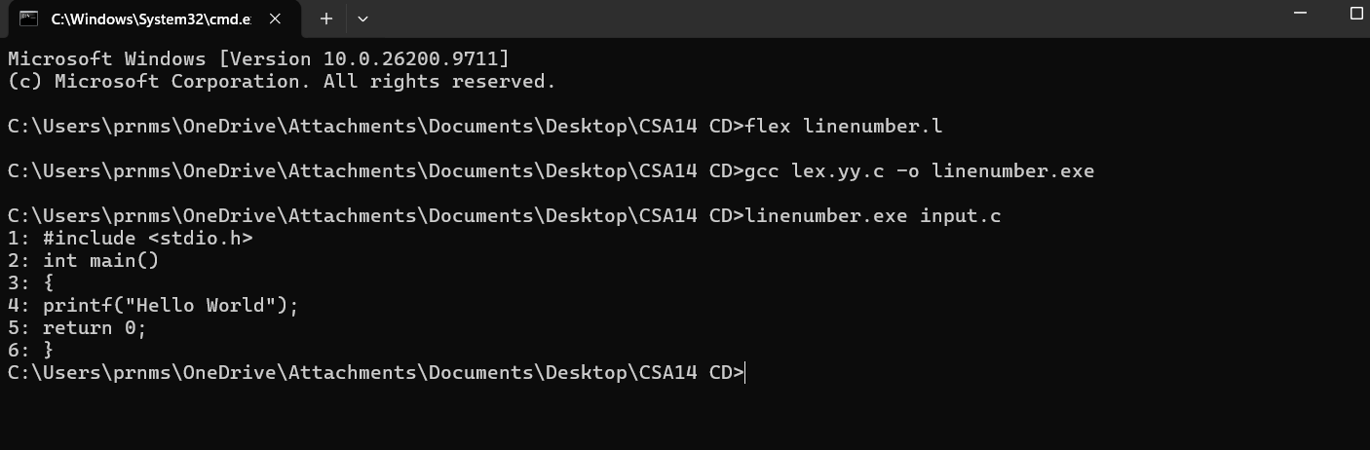

7. Write a LEX program to count the number of comment lines in a given C program and eliminate them and write into another file.

%{
#include <stdio.h>
#include <stdlib.h>

int count = 0;
FILE *out;
%}

%%

"//".* { count++; }
"/*"([^*]|\*+[^*/])*\*+"/" {
count++;
}
\n { fprintf(out, "\n"); }
. { fprintf(out, "%s", yytext); }

%%

int yywrap(void)
{
return 1;
}

int main(int argc, char *argv[])
{
if (argc < 2)
{
printf("Usage: %s <filename.c>\n", argv[0]);
return 1;
}

yyin = fopen(argv[1], "r");
if (yyin == NULL)
{
printf("Error: Cannot open input file\n");
return 1;
}

out = fopen("output.c", "w");
if (out == NULL)
{
printf("Error: Cannot create output file\n");
fclose(yyin);
return 1;
}

yylex();

printf("Number of comment lines = %d\n", count);
printf("Comments removed successfully.\n");
printf("Output written to output.c\n");

fclose(yyin);
fclose(out);
return 0;
}

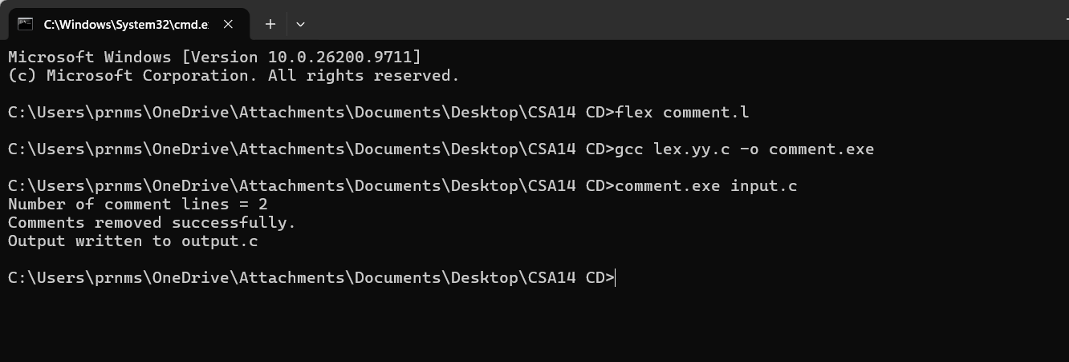

8. Write a LEX program to identify the capital words from the given input.

%{
#include <stdio.h>
%}

%%

[A-Z]+ { printf("Capital word: %s\n", yytext); }
.|\n ;

%%

int yywrap(void)
{
return 1;
}

int main(void)
{
printf("Enter the input:\n");
yylex();
return 0;
}

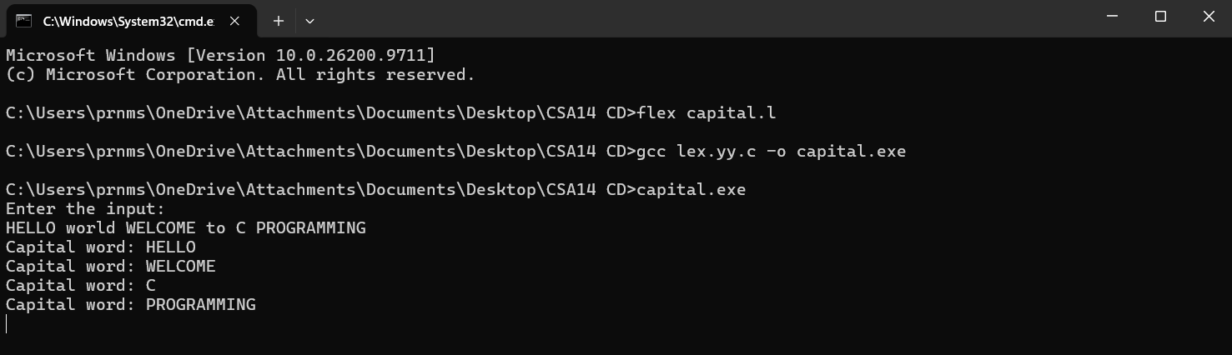

9. Write a LEX Program to convert the substring abc to ABC from the given input string

%{
#include <stdio.h>
%}

%%

abc { printf("ABC"); }
.|\n { printf("%s", yytext); }

%%

int yywrap(void)
{
return 1;
}

int main(void)
{
printf("Enter a string:\n");
yylex();
return 0;
}

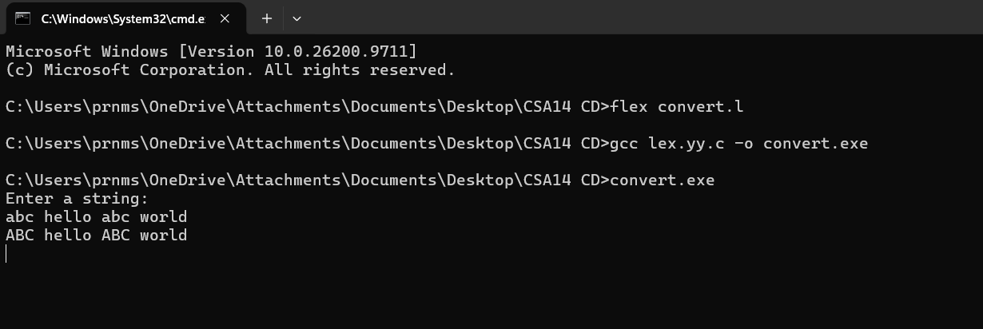

10. Implement a LEX program to check whether the mobile number is valid or not.

%{
#include <stdio.h>
#include <string.h>
%}

%%

[6-9][0-9]{9} { printf("Valid mobile number\n"); }
[0-9]+ { printf("Invalid mobile number\n"); }
. { printf("Invalid mobile number\n"); }

%%

int yywrap(void)
{
return 1;
}

int main(void)
{
char mobile[100];

printf("Enter mobile number: ");
scanf("%99s", mobile);

YY_BUFFER_STATE buffer = yy_scan_string(mobile);
yylex();
yy_delete_buffer(buffer);

return 0;
}

